1.2

1)   
SELECT * FROM book  
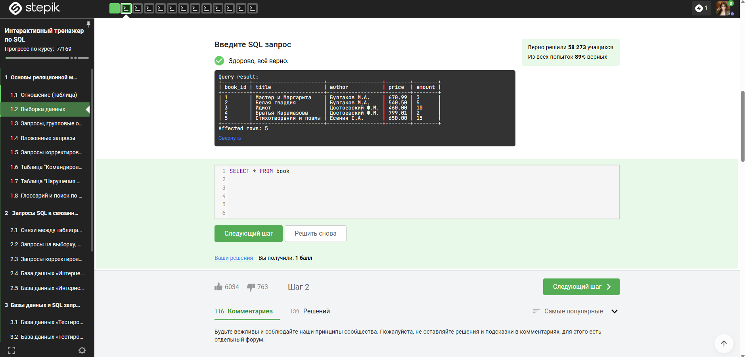  
2)  
 SELECT author,title,price  
FROM book  
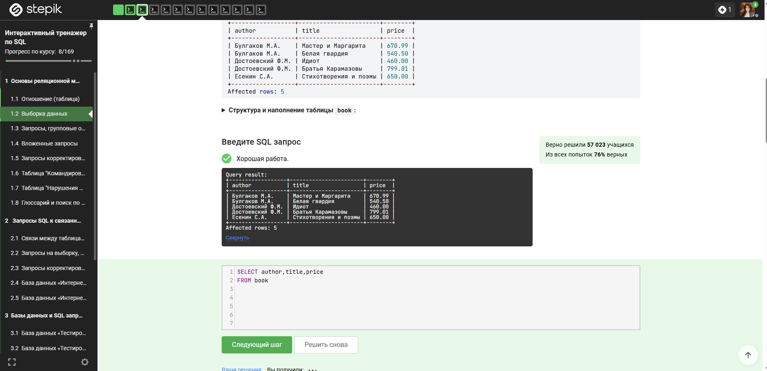

3)  
SELECT title AS 'Название',  
author AS 'Автор'  
FROM book  
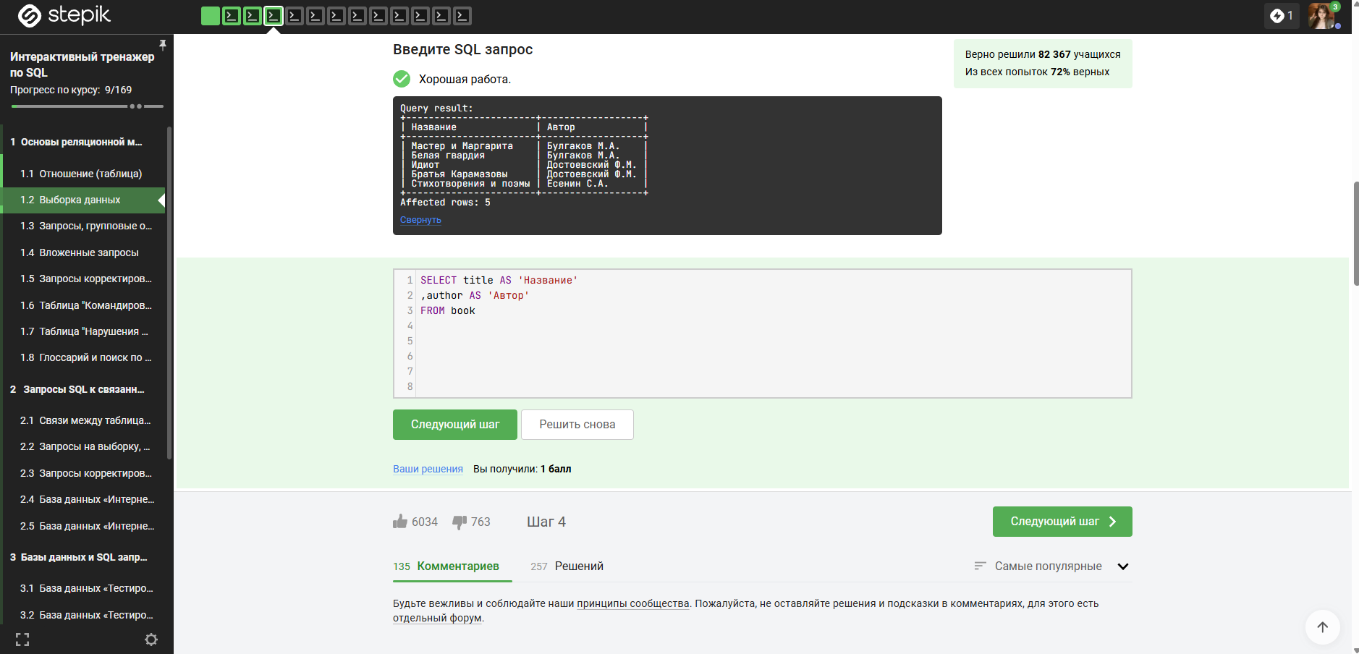

4)  
SELECT title  
,amount  
,amount * 1.65 as 'pack'  
FROM book  
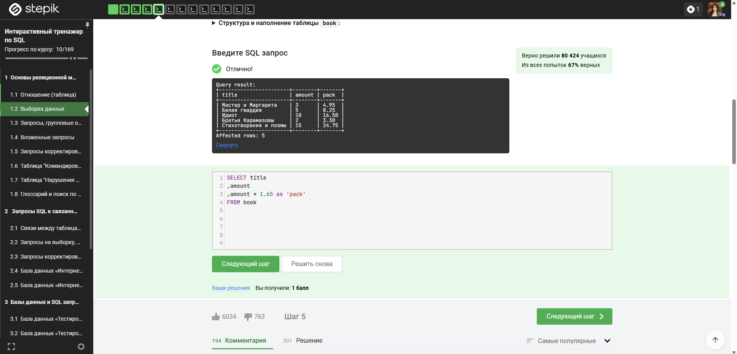

5)  
SELECT title  
,author  
,amount  
,round((price * 0.7),2) as new_price  
FROM book  
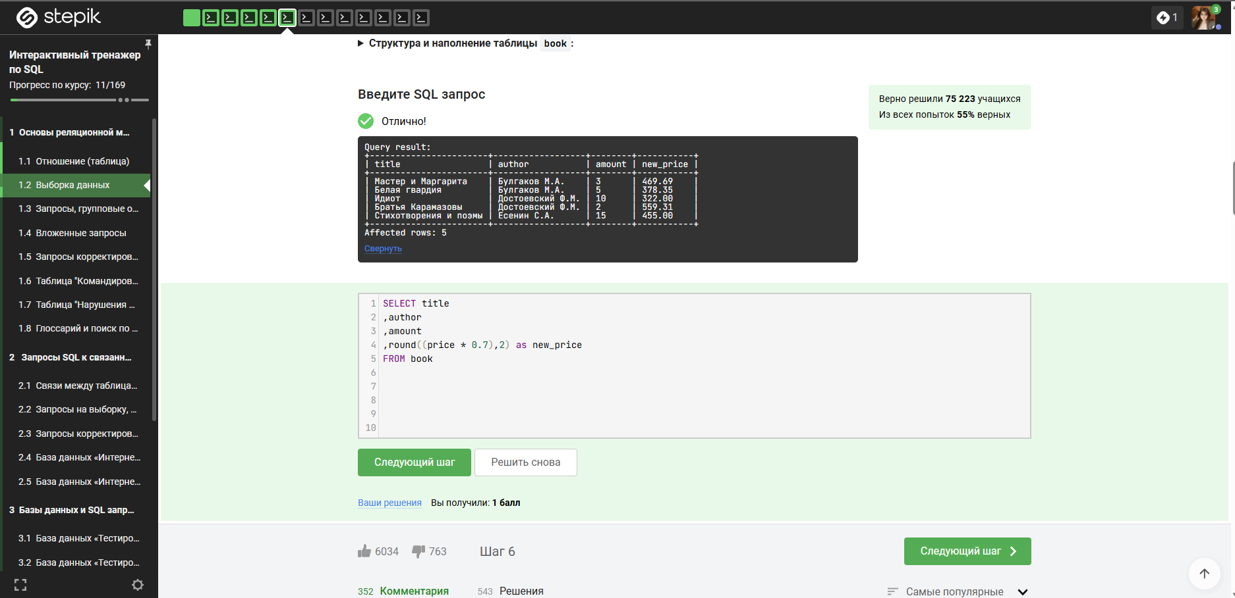

6)  
SELECT author  
,title  
,CASE WHEN author = 'Булгаков М.А.' THEN round((price * 1.1),2)   
WHEN author = 'Есенин С.А.' THEN round((price * 1.05),2)  
ELSE price  
END as new_price  
FROM book  
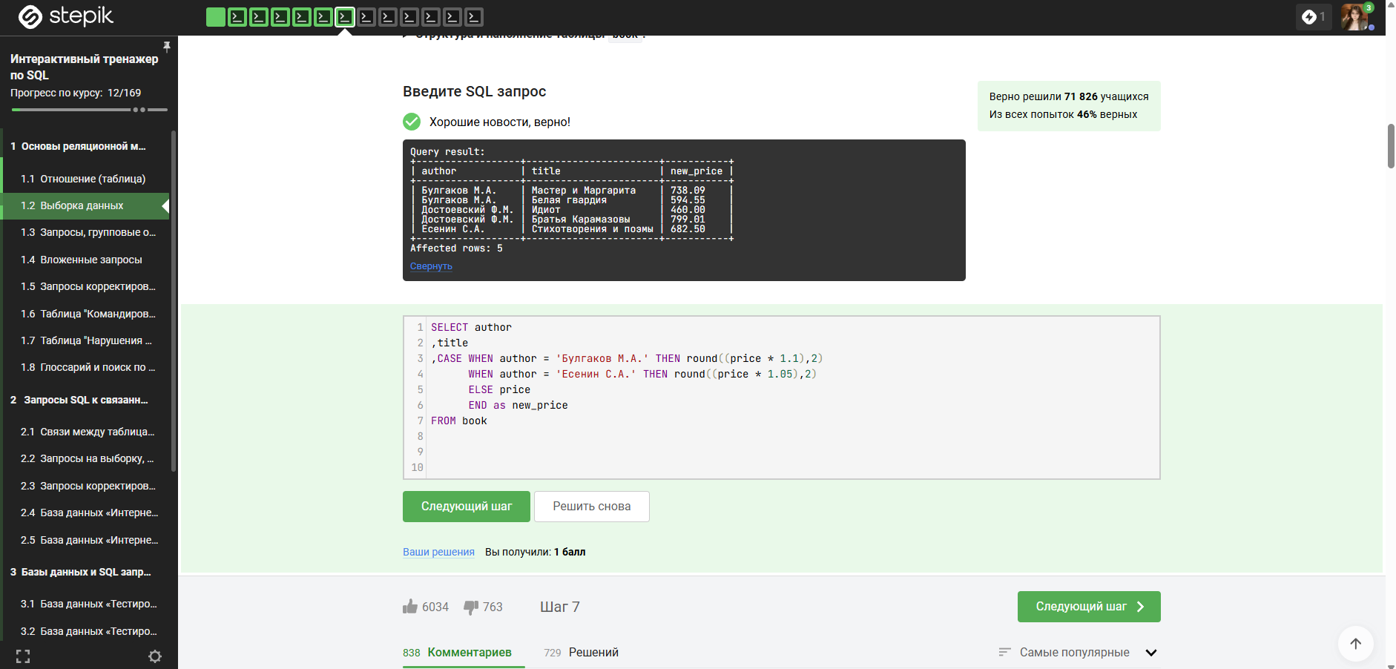

7)  
SELECT   
author  
,title  
,price  
FROM book  
WHERE amount < 10  
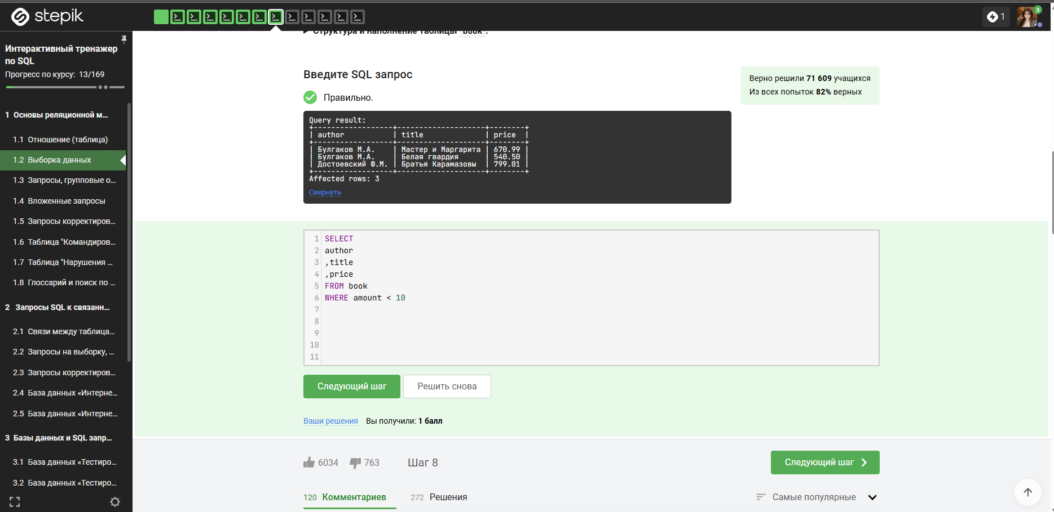

8)  
SELECT  
title  
,author  
,price  
,amount  
FROM book  
where price not between 500 and 600  
AND  
price * amount >= 5000  
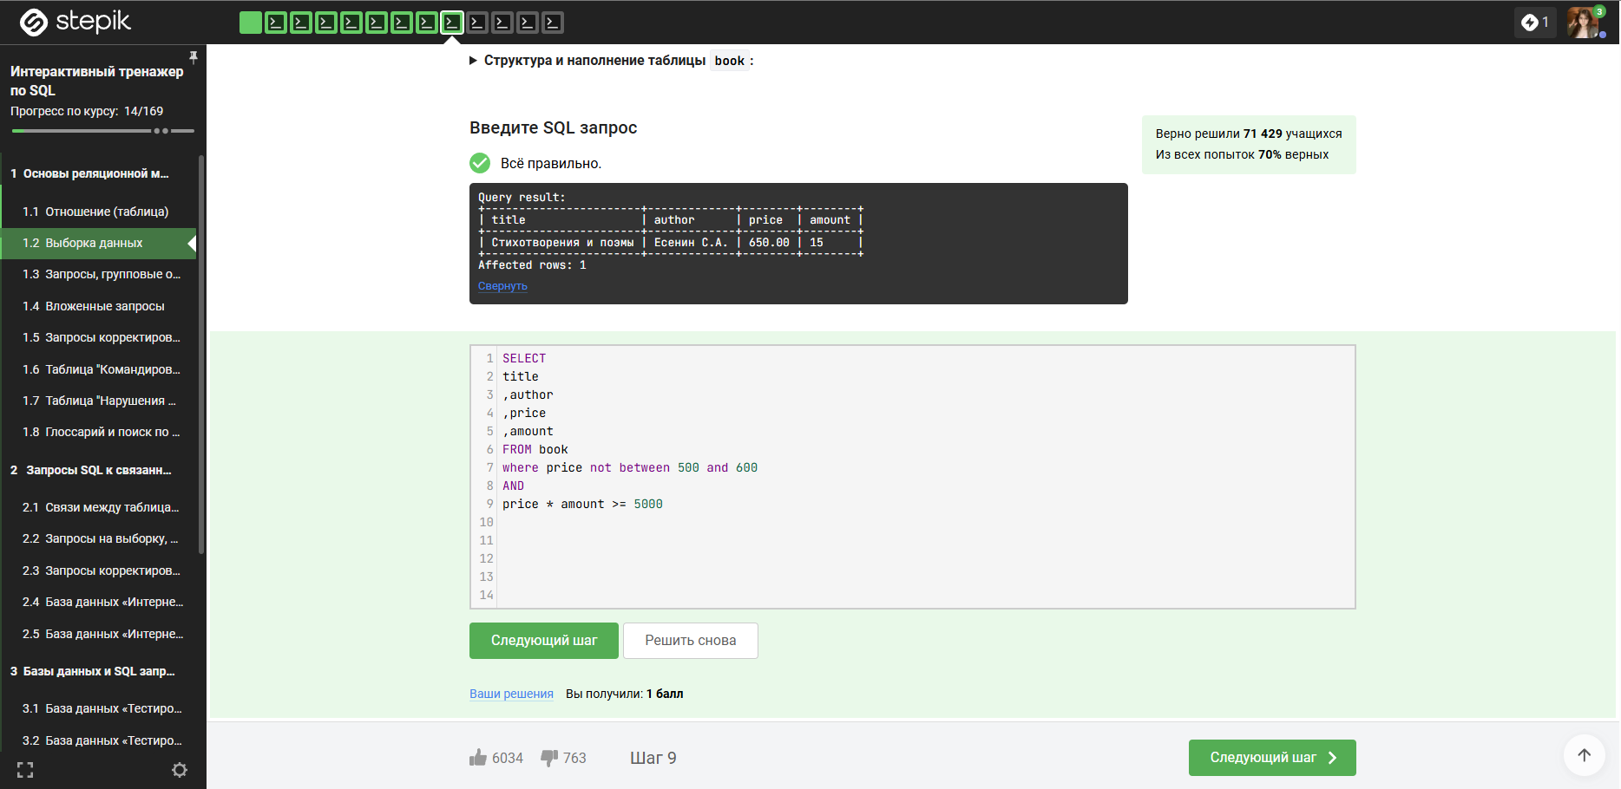

9)  
SELECT   
title  
,author  
FROM book  
WHERE price BETWEEN 540.50 and 800  
AND  
amount IN (2,3,5,7)  
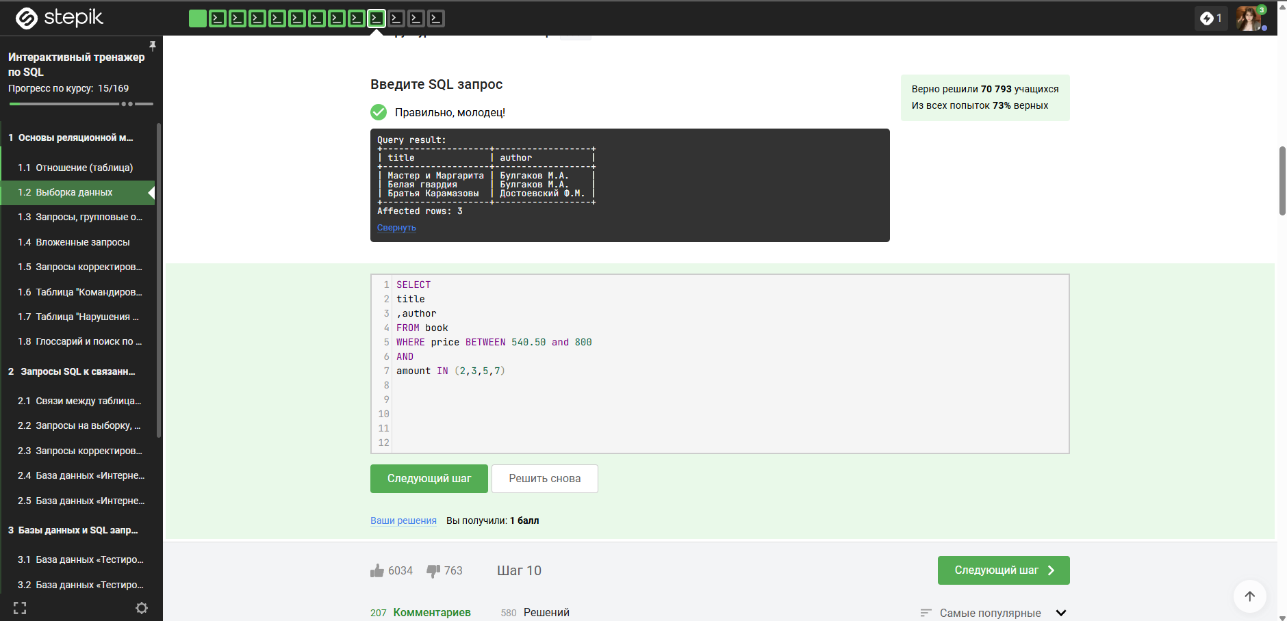

10)  
SELECT   
author  
,title  
FROM book  
WHERE amount BETWEEN 2 and 14  
ORDER BY author DESC,  
title ASC  
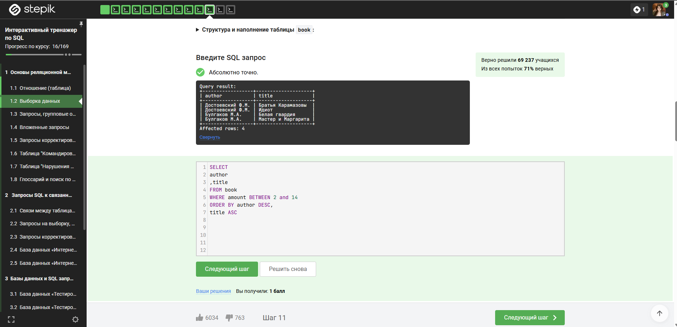

12)  
SELECT title  
,author  
,price  
,SUM(amount) as sumAM  
FROM book  
GROUP BY author  
,price  
,title  
